A Project Report

On

**Water Level Monitoring and Pump**

**Controller**

Submitted in partial fulfillment of

The requirement of

**PROJECT-III**

(BIT 206CO)

Of

BACHELOR OF INFORMATION TECHNOLOGY

**Submitted to**



**Purbanchal University**

**Biratnagar, Nepal**

**Submitted By**

Bhavishek Lama (330616)

Prasant Khadka (330633)

Sulav Achary (330645)

**KANTIPUR CITY COLLEGE**

Putalisadak, Kathmandu

June, 2025

A Project Report

On

**Water Level Monitoring and Pump**

**Controller**

Submitted in partial fulfillment of

The requirement of

**PROJECT-III**

(BIT 206CO)

Of

BACHELOR OF INFORMATION TECHNOLOGY

**Submitted to**

**Purbanchal University**

**Biratnagar, Nepal**

**Submitted By**

Bhavishek Lama (330616)

Prasant Khadka (330633)

Sulav Achary (330645)

**Project Supervisor**

Er.Rabi Shrestha

**KANTIPUR CITY COLLEGE**

Putalisadak, Kathmandu

June, 2025

# **Abstract**

Water Level Monitoring and Pump Controller project is a microcontroller based embedded system designed to automate water management in domestic settings. This system utilizes ultrasonic sensors to measure the water levels in a storage tank and a daily-use tank, providing accurate real-time monitoring. Based on predefined thresholds, it automatically controls a water pump to maintain optimal water levels, ensuring efficient water usage and preventing overflows. Additionally, it incorporates a communication module (e.g., GSM) to notify the user via SMS when critical water levels are reached or actions are taken, such as pump activation or shutdown. The system is built around the 8051 microcontrollers, offering cost-effective operation, low power consumption, and reliable performance.

This documentation details the design, components, working principles, software implementation, and simulation results, aiming to present a robust and practical solution for smart water management.

**Acknowledgment**

We would like to express our heartfelt gratitude to everyone who has encouraged us to work on this project. First and foremost, we’d like to express our gratitude to the entire team of Kantipur City College (KCC) for this chance, especially to the Principal of Kantipur City College, who assisted us in furthering our knowledge in this field.

In addition, we would like to express our special gratitude to our supervisor, Er. Rabi Shrestha, who has consistently encouraged, inspired and provided us with a wealth of information that has been beneficial. His advice was helpful in completing this assignment. We could not have asked for a better supervisor, counselor, or mentor. We also extend our Special thanks to Er. Govind Chaudhary, the hardware instructor for his invaluable help in hardware integration part of this project.

This project would not have been possible without the assistance of each member, as well as the entire class, who offered suggestions, shared their experiences, and provided advice throughout the project. We are grateful for this. Finally, we would like to express our gratitude to our friends and colleagues who supported us directly and indirectly throughout this project.

**Declaration**

I declare that this project report titled ‘Water Level Monitoring and Pump Controller’ submitted in partial fulfillment of the BIT is a record of original work carried out by us under the supervision of Er. Rabi Shrestha and has not formed the basis for the award of any other degree or diploma, in this or any other Institution or University. In keeping with the ethical practice in reporting scientific information, due acknowledgements have been made wherever the findings of others have been cited.

Bhavishek Lama (330616)  
Prasant Khadka (330633)  
Sulav Achary (330645)

**Supervisor's Approval**

This is to certify that the major project entitled ‘Water Level Monitoring and Pump Controller' was undertaken and demonstrated by Bhavishek Lama, Prashant Khadka and Sulav Acharya has been successfully completed under my supervision as a partial fulfillment of the requirements for the degree of BIT, 3rd semester under Purbanchal University. I, henceforth, approve this project to be awarded the certificate by the concerned authority.

During supervision, I found students hardworking, skilled and ready to undertake any professional work related to this field in future.

-------------------------

Er. Rabi Shrestha

Project Supervisor

Department of IT  
Kantipur City College

**Table of Content**

**Abstract** i

**1: Introduction** 1

**1.1 Background** 1

**1.2 Problem Statement** 1

**1.3 Objectives** 2

**1.4 Scope and Limitation** 2

**1.5 Hardware Requirements** 2

**1.6 Hardware Specifications** 3

**1.7 Organization of Documentation** 6

**2: Literature Overview** 7

**3: System Design** 9

**3.1 Block Diagram** 9

**3.2 Circuit Diagram** 11

**3.3 Algorithm** 12

**3.4 Flowchart** 14

**3.5 Tools and Techniques** 15

**3.6 Library and Functions** 16

**3.7 Testing and debugging** 18

**4: Methodology and Scheduling** 21

**4.1 Schedule** 21

**4.2 Assignment and Roles** 22

**4.3 Gantt Chart** 22

**5: Conclusion** 23

**Chapter 6: Reference** 24

**Appendix A: Pin Diagram and Image** 25

**Appendix B Datasheet** 29

**List of Tables**

Table 1: System Specification 15

Table 2: Library Files 16

Table 3: Functions Used 16

Table 4: Test Cases 18

Table 5: Roles and Responsibility 22

**List of Figures**

Figure 1: Block Diagram 9

Figure 2: Circuit Diagram 11

Figure 3: Flowchart 14

Figure 4: Gantt Chart 22

# **1: Introduction**

This project involves the use of 8051 microcontroller to develop a constructive and effective system. The microcontroller is very versatile in its use as such many of our day-to-day activities can be automated through its use. An automated intrusion detection system is very practical as it does not need any monitoring, and the system will work as it is programmed. The basics of the operation are to send message to the contact upon detecting any kind of activity.

## **1.1 Background**

Manual water level monitoring and pump control often lead to water wastage and inefficiency. To address this, the Water Level Monitoring and Pump Controller project automates the process using ultrasonic sensors and an 8051 microcontroller. It monitors water levels in both storage and daily-use tanks and controls the pump accordingly. A GSM module is used to send real-time notifications to the user. This project focuses on developing a smart water management system using microcontroller-based automation and communication modules to reduce human effort, conserve resources, and promote sustainable water usage.

## **1.2 Problem Statement**

In many residential and commercial settings, water tanks are still filled and maintained manually, often leading to problems such as water overflow, pump dry-run, and inefficient usage. This manual process is not only time-consuming and unreliable but also prone to human error, resulting in water wastage and potential damage to pumping systems. To address these issues, there is a need for an automated, cost-effective, and reliable solution that can monitor water levels in real time, intelligently control pump operations, and alert users during critical conditions.

## **1.3 Objectives**

The objectives of the project are as follows:

* To automate water tank refilling using a microcontroller-based system.
* To prevent dry running and overflow of the motor.
* To send alert messages to users via GSM when the motor is turned ON or OFF.

## **1.4 Scope and Limitation**

Although it is a useful and smart system, it has some limits based on how it works and the technology used.

* It stops working if there is no electricity or backup power.
* SMS alerts might be late if the mobile network is weak.
* It cannot check if the water is clean or if there is any leakage.
* The system follows fixed rules and cannot be controlled remotely.
* It is designed for automatic control only, not for complex user customization.

## **1.5 Hardware Requirements**

The hardware components that are required are as follow:

* 8051 family microcontroller and development kit
* Programmer
* Ultrasonic Sensor
* GSM module SIM800L
* Relay Module
* 16x2 LCD
* 10k potentiometer
* Water pump

## **1.6 Hardware Specifications**

**1) 8051 microcontrollers**

* 4 KB on-chip ROM (Program memory).
* 128 bytes on-chip RAM (Data memory).
* The 8-bit data bus (bidirectional).
* 16-bit address bus (unidirectional).
* Two 16-bit timers.
* Instruction cycle of 1 microsecond with 12 MHz crystal.
* Four 8-bit input/output ports.
* 128 user-defined flags.
* Four register banks of 8 bit each.
* 16-byte bit-addressable RAM.
* The general-purpose registers are 32 each is 8-bit.
* 8051 has two external and three internal interrupts.
* It has a 16-bit program counter and data pointer.

**2)** **SIM800L GSM/GPRS Module:**

* Supply Voltage: 3.8V – 4.2V
* Recommended Supply voltage: 4V
* Power Consumption:
  + sleep mode < 2.0mA
  + idle mode < 7.0mA
  + GSM transmission (avg): 350 mA
  + GSM transmission (peak): 2000mA
* Module Size: 25×23 mm
* Interface: UART (max. 2.8V) and AT commands
* SIM card socket: microSIM (bottom side)
* Supported frequencies: Quad Band (850/950/1800/1900 MHz)
* Antenna connector: IPX
* Status Signaling: LED

**3) 16×2 Alphanumeric LCD:**

* Displays 16 characters per line with 2 lines (16x2 = 32 characters total).
* Operates at 4.7V to 5.3V (typically used at 5V with microcontrollers).
* Uses the HD44780 controller (compatible with 8051 microcontroller).
* Has an 8-bit data bus (also supports 4-bit mode to save I/O pins).
* Supports both alphanumeric and custom characters.
* Each character is displayed in a 5×8 dot pixel matrix.
* Features a parallel interface for fast data communication.
* Includes 16 pins (RS, RW, EN, D0–D7, VCC, GND, VEE, LED+/-).
* Supports basic commands like Clear Display, Cursor Shift, Display On/Off, etc.
* Can be interfaced easily with 8051 using simple timing and logic.
* Has a built-in LED backlight for visibility in low light.
* Cursor control and blinking options available through commands.

**4) 10k Potentiometer:**

* Resistance value: 10 kilo-ohms (10kΩ).
* Used to adjust the contrast of the 16x2 LCD display.
* Has three terminals: two fixed ends and one adjustable wiper.
* Middle terminal (wiper) connected to LCD contrast pin (VEE).
* Works as a voltage divider between VCC and GND.
* Adjustable manually using a knob or screwdriver.
* Typically allows 270° of rotation for smooth control.
* No external power required — purely passive component.
* Compact in size and easily mountable on breadboards or PCBs.
* Provides stable and precise control of display visibility.

**5) Ultrasonic Sensor:**

* Used for measuring distance by using ultrasonic sound waves.
* Typical operating voltage: 5V DC.
* Operating current: around 15 mA.
* Measuring range: 2 cm to 400 cm (approx.).
* Accuracy: ±3 mm under ideal conditions.
* Has four pins: VCC, GND, TRIG, and ECHO.
* TRIG pin is used to send a 10µs pulse to start measurement.
* ECHO pin sends back the reflected pulse duration in microseconds.
* Distance is calculated using the time taken for echo to return.
* Compatible with 8051 microcontrollers for water level measurement.

**6) Relay Module:**

* Used to control high-voltage AC devices using low-voltage DC signals.
* Operates typically on 5V DC input (signal voltage from microcontroller).
* Can switch AC loads up to 250V at 10A or DC loads up to 30V at 10A.
* Contains an electromagnetic relay, transistor driver, and flyback diode for protection.
* Has three output terminals: NO (Normally Open), NC (Normally Closed), and COM (Common).
* Includes input pins: VCC, GND, and IN (control signal from microcontroller).
* Provides electrical isolation using an optocoupler (in opto-isolated modules).
* LED indicator shows relay ON/OFF status.
* Allows 8051 microcontroller to safely control devices like motors or pumps.
* Easy to interface with digital outputs using simple HIGH/LOW logic.

**7) DC Motor**

* Voltage Range: 6V-12V
* Nominal Voltage: 12V
* Current: 0.14A
* RPM: 12,500 max
* Torque: 44.2g/cm
* Terminal Type: Solder
* Shaft Diameter: 2.27mm
* Shaft Length: 12mm
* Size: 27.57mm dia. x 37.62mm length.

**Note: For Hardware data-sheet, refer to the relevant appendix (data-sheet source: manufacture website)**

## **1.7 Organization of Documentation**

**Chapter 1:** It contains the general detail and introduction of the project. It contains the main objective of the project with features of the project. It also contains the scope and limitation of the project. It contains the brief idea of the components and hardware used in the project.

**Chapter 2:** It contains overview of the similar projects that used similar components. We studied how those components were used in those projects and implemented the part in our project.

**Chapter 3:** It contains algorithm and flowchart depicting the workflow of the system. It also has circuit diagram, block diagram and use of functions and library files and some of the test cases.

**Chapter 4:** It contains schedule, roles and assignments and Gantt Chart to show the stages of the system of the project

**Conclusion**: It contains the overall summary of the whole project and the overall assembly of the project.

# **2: Literature Overview**

**Project 1: Ultrasonic Water Level Indicator Using 8051 Microcontroller (Learn Electronics India)**

**Introduction:**

This review examines the "Ultrasonic Water Level Indicator Using 8051 Microcontroller" from Learn Electronics India, which details a system for monitoring water levels using the 8051 microcontroller and an HC-SR04 ultrasonic sensor. The setup measures water levels safely and displays them on an LCD, focusing on precision and real-time feedback. This source is highly relevant to the project’s requirement for accurate water level monitoring and display in percentage form for both tanks.

**Pros:**

* Non-Contact Measurement
* Accurate Monitoring
* User-Friendly

**Cons:**

* Limited Control:
* Single Tank Design
* No Alerts

**Project 2: Water Level Controller using 8051 Microcontroller (Electronicshub)**

**Introduction:**

This project focuses on the "Water Level Controller using 8051 Microcontroller" from Electronicshub, which outlines a system for monitoring and controlling water levels in a tank using the 8051 microcontrollers. The design employs a contact-based method with conducting wires as sensors, an LCD for display, and a relay to control the pump, offering a straightforward approach to water management. This source provides a foundation for understanding basic automation in water pump systems, relevant to the project's goals of level monitoring and pump control.

**Pros:**

* Simplicity: Uses basic components and a straightforward wire-based sensing method, making it easy to implement.
* Cost-Effective: Relies on inexpensive materials like conducting wires and a standard relay.
* Clear Display: Integrates an LCD to show tank status, enhancing user interaction.

**Cons:**

**Contact-Based Sensing:** Wires in water may corrode over time, reducing reliability compared to non-contact methods like ultrasonic sensors.

**Limited Features:** Lacks advanced features like SMS notifications, dry run protection, or manual control, requiring additional design for the project.

**Single Tank Focus:** Designed for one tank, needing adaptation for monitoring both reservoir and overhead tanks.

# **3: System Design**

The components are selected based on the system’s need for autonomous operation after installation. The system is designed to deliver accurate results within a specific time frame without manual intervention. Considering scalability, it is intended for small-scale use, such as a single home or water system. Therefore, the overall design is kept simple, efficient, and easy to implement.

## **3.1 Block Diagram**

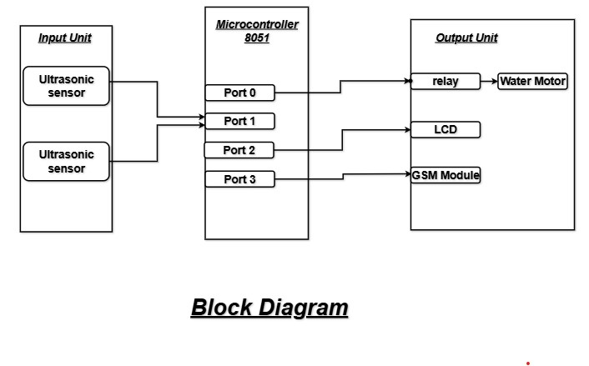Figure 1: Block Diagram

1. INPUT UNIT

It is the unit with which the user interacts and provides input to the system. It is responsible for providing some information to the microcontroller that is processed. The input unit has two parts:

* Ultrasonic Sensors ( HC-SR04)

Ultrasonic sensors are the core input devices used to measure the water levels. Each tank is equipped with one ultrasonic sensor mounted at the top. These sensors work by emitting ultrasonic waves and measuring the time it takes for the echo to return after hitting the water surface. This time is then used to calculate the distance to the water surface, which determines the current water level.

* + Working Principle:
* Distance = (Time × Speed of Sound) / 2
* The division by 2 accounts for the to-and-fro travel of the ultrasonic pulse.

1. MICROCONTROLLER

The 8051 microcontroller is the main processing unit of the system and will be used connect all the input and output unit. It is an 8-bit microcontroller. It is built with 40 pins, 4kb of ROM storage and 128 bytes of RAM storage, two 16-bit timers. It consists of are four parallel 8-bit ports, which are programmable as well as addressable as per the requirement. An on-chip crystal oscillator is integrated in the microcontroller having crystal frequency of 11.0592 MHz

1. OUTPUT UNIT

The output unit is used to show the result of the interaction with the user. The output unit has three parts:

1. DC motor- It is used to operate the lock mechanics of the system. It will open the mechanics if the pass-code is correct, after which it waits for some time and will automatically close the lock.
2. SIM 900D - It is used to send an alert message to the user to notify them that the pass-code has been entered wrong 3 times. Low cost and quad band frequency makes this module perfect for projects. Communication is established through serial communication and instruction is given through microcontroller.
3. LCD - It is used to show the result of the interaction and is to display the system status.

## **3.2 Circuit Diagram**

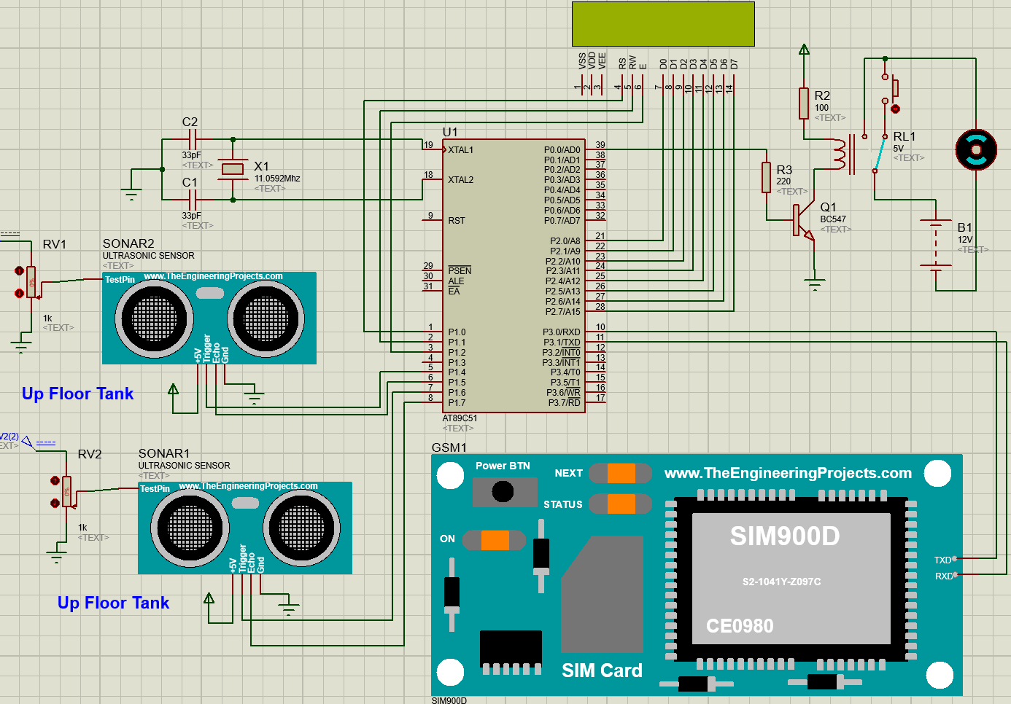

Figure 2: Circuit Diagram

## **3.3 Algorithm**

Step 1: START

Step 2: Initialize LCD, SIM (GSM) module, and motor.

  Display "CHECKING WATER LEVEL" on LCD.

  Send SMS "System Started: Water Level Monitoring".

Step 3: Measure water level of Tank 2 (Source Tank).

Step 4: Measure water level of Tank 1 (Destination Tank).

Step 5: Is Tank 2 level ≥ 10 % (sufficient water)?

→ If YES:

  Check Tank 1 level:

   → If Tank 1 ≤ 25%:

     - Turn motor ON.

     - Display "Motor is ON!! Tank1 Near Empty !!".

     - If SMS not already sent: Send SMS "Alert: Tank 1 Near Empty! Motor ON".

   → If Tank 1 > 25% and ≤ 95%:

     - Keep motor ON.

     - Display filling status (e.g., Mid, Over Mid, Near Full).

   → If Tank 1 > 95% (Full):

     - Turn motor OFF.

     - Display "Motor is OFF!! Tank 1 Full".

     - If SMS not already sent: Send SMS "Alert: Tank 1 Full! Motor OFF".

   → While (Tank 1 ≤ 95%) AND (Tank 2 ≥ 10 cm):

     - Keep motor ON.

     - Display "Filling Tank 1".

     - Recheck Tank 1 and Tank 2 levels.

→ If NO (Tank 2 < 10 cm):

  - Turn motor OFF.

  - Display "Tank 2 Empty!! Fill Tank 2".

  - If SMS not already sent: Send SMS "Alert: Tank 2 Empty! Fill Tank 2".

Step 6: Repeat from Step 3 continuously.

Step 7: STOP

## **3.4 Flowchart**

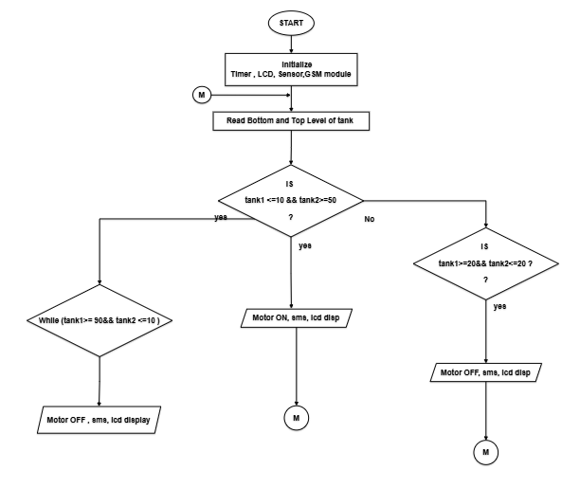

Figure 3: Flowchart

## **3.5 Tools and Techniques**

The project was done in:

* Software development tool: Keil 5
* Circuit Simulation Software: Proteus 8

Table 1: System Specification

|  |  |
| --- | --- |
| OS Name | Microsoft Windows 11 |
| System manufacturer | Acer |
| Processor | AMD Ryzen 7, 5000H |
| RAM | 16 GB |
| System type | X64-based PC |

## **3.6 Library and Functions**

Table 2: Library Files

|  |  |
| --- | --- |
| Header File | Description |
| #include<reg51.h> | All the special functions registers address mapped to predefined variable names. |
| #include <intrins.h> | provides access to intrinsic functions like _nop_() that map directly to single machine-level instructions, enabling precise control of timing and operations |

Table 3: Functions Used

|  |  |
| --- | --- |
| Functions | Description |
| void delay(unsigned int ms) | To create a delay |
| void delay_us(unsigned int ms) | To create a delay for sonar |
| void LCD_cmd(unsigned char command) | To input command to LCD |
| void LCD_data_write(unsigned char dataa) | To input data to LCD |
| void LCD_string_write (unsigned char *string) | To display string in LCD |
| void LCD_init() | To initialize the LCD |
| void LCD_off() | To turn the LCD off |
| void sms(unsigned char *num1, unsigned char *msg) | AT commands to send SMS |
| Void sim_init() | Initializes the serial communication (UART) for the GSM module |
| void tx(unsigned char) | Transmits a single character via UART |
| void tx_string(unsigned char *) | Transmits a string of characters via UART |
| num_to_string | Converts a number to a string format (useful for displaying numerical data on the LCD). |
| trigger_sensor | Sends a pulse to the first ultrasonic sensor to trigger the measurement. |
| measure_distance | Measures the distance using the first ultrasonic sensor and returns the duration of the echo. |
| calculate_distance_cm | Converts the measured duration of the echo into a distance in centimeters. |
| ret_distance | Measures the distance for the second tank and updates the LCD with the height. |
| lcd_display_height | Displays the height of water in the second tank on the LCD. |

## **3.7 Testing and debugging**

Along with the development of this project, we encountered several errors and bugs in both simulations and hardware assembly and integration of components. Here below we have listed a few of them.

Table 4: Test Cases

|  |  |  |  |  |
| --- | --- | --- | --- | --- |
| **S.N.** | **Test Case** | **Expected Outcome** | **Actual Outcome** | **Remarks** |
| 1 | Check LCD Initialization | LCD displays "CHECKING WATER" and "LEVEL" on the screen. | LCD displays "CHECKING WATER" and "LEVEL". | Pass |
| 2 | Check Distance Measurement (Tank 1) | Sensor 1 returns a valid distance measurement. | Distance measured is within expected range | Pass |
| 3 | Check Distance Measurement (Tank 2) | Sensor 2 returns a valid distance measurement. | Distance measured is wrong | fail |
| 3 | Check Distance Measurement (Tank 2) | Sensor 2 returns a valid distance measurement. | Distance measured is within expected range | Pass |
| 4 | Tank 2 Low (height < 10) | LCD shows "Tank 2 Empty" and "Fill Tank 2", SMS is sent to phone number. | LCD shows "Tank 2 Empty" and "Fill Tank 2", SMS is sent to phone number. | Pass |
| 5 | Tank 2 High (height >= 10) and Tank 1 Low (height1 <= 25) | LCD shows "Motor is ON" and "Tank 1 Near Empty". | LCD shows "Motor is ON" and "Tank 1 Near Empty". | Pass |
| 6 | Tank 2 High (height >= 10) and Tank 1 Mid (height1 > 25 && height1 <= 70) | LCD shows "Motor is ON" and "Tank 1 Around Mid". | LCD shows "Motor is ON" and "Tank 1 Around Mid". | Pass |
| 7 | Tank 2 High (height >= 10) and Tank 1 High (height1 > 75 && height1 <= 95) | LCD shows "Motor is ON" and "Tank 2 Near Fill". | LCD shows "Motor is ON" and "Tank 2 Near Fill". | Pass |
| 8 | Tank 1 Full (height1 > 95) | LCD shows "Motor is OFF" and "Tank 1 Full". | LCD shows "Motor is OFF" and "Tank 1 Full". | Pass |
| 9 | SIM800L Failure (SIM not initialized) | No SMS is sent, LCD displays an error message like "SIM Error". | SMS is not sent; LCD displays "SIM Error". | Fail |
| 10 | SIM800L module initializes properly and sends SMS when required | SMS is successfully sent; LCD displays "SMS Sent" or similar confirmation message | SMS sent successfully; LCD shows "SMS Sent" | PASS |
| 11 | Incorrect Echo Pin Trigger (Faulty Sensor) | Sensor should not trigger or produce invalid. | Sensor fails to trigger or returns invalid ". | Fail |
| 12 | Ultrasonic sensor correctly triggers and returns accurate distance | LCD displays correct distance without showing "Sensor Error" | Accurate water level is shown on LCD; no error messages observed | PASS |

# **4: Methodology and Scheduling**

This project is a combination of DC motor, LCD and GSM module. The rain sensor detects rain and activates the system. After detection, LCD is activated along with DC motor and GSM module. The motor is responsible for retrieving the clothes and the GSM module is responsible for sending message to the relevant number.

## **4.1 Schedule**

**Week 1:** Concept Submission

* Gather a simple idea for the project with an expected plan for the project.

**Week 2:** Research and Analysis

* Identify the hardware requirements and sensors.
* Research available components
* Create a project plan.

**Week 3:** System Design

* Design and develop the basic simulation in Proteus.
* Test and debug the code for simulation.

**Week 3-10:** Coding and Assembly

* Check simulation for errors.
* Assemble hardware components.

**Week 6-12:** Debugging and Testing

* Test the program for semantic and syntax error.
* Test the system for errors.

**Week 2-12:** Documentation

* Basic documentation will begin from the beginning.
* Progress will be added simultaneously according to the level of completion.

## **4.2 Assignment and Roles**

Table 5: Roles and Responsibility

|  |  |
| --- | --- |
| Member Name | Roles and Responsibility |
| Bhavishek Lama | GSM module, ultrasonic sensor / Chapter 1,3, Reference, Conclusion |
| Prasant khadka | LCD, ultrasonic sensor / Chapter 3,4, Appendix A and B |
| Sulav Acharya | Water pump and relay / Chapter 1 |

## **4.3 Gantt Chart**

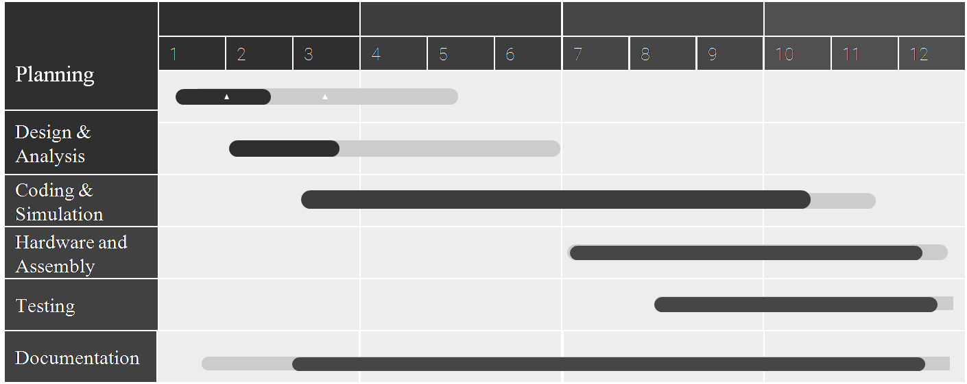

Figure 4: Gantt Chart

# **5: Conclusion**

The project is a microcontroller-based hardware project which uses simple electronic components to provide convenience in everyday life. It also aims to better our skills in handling such electronic components and our use of embedded systems. The project was assembled onto a box by fixing the LCD on the front, H-bridge and breadboard on the top with an external power supply connected to it, and the GSM module on the side. The final system successfully automates the process of protecting clothes from rain, provides user notifications, and operates efficiently by using the microcontroller's idle mode.

# **Chapter 6: Reference**

1. **Mazidi, Muhammad Ali.** *The 8051 Microcontroller and Embedded.* **2023.** *EmbeTronicx.* [Online] 2023.
2. *Electronicshub.* [Online] [Cited: 10 10, 2023.] https://www.electronicshub.org/gsm-interfacing-8051-microcontroller/.
3. https://lastminuteengineers.com/sim800l-gsm-module-arduino-tutorial/
4. Hegade, P., Nayak, S., Alagundi, P., & MR, K. (2016). Automatic protection of clothes from rain. *International Journal of Advanced Research in Computer and Communication Engineering*, 5(4), 363-368.
5. Janhavi V., Sahanashankar, Sanjana S., Vidya H. G., & Yuvarani S. R. (2023). Automatic Protection of Clothes from Rain. *International Journal of Advanced Research in Computer and Communication Engineering (IJARCCE)*, 12(4).
6. Mazidi, M. A., McKinlay, R. D., & Causey, J. G. (2006). *The 8051 Microcontroller and Embedded Systems: Using Assembly and C*. Pearson Prentice Hall.
7. Modi, A., Shivaraja, K., Kumara, S. K., & Vali, S. S. (2016). Rain Water Detection and Automatic Cloth Retrieval Machine. *International Journal of Creative Research Thoughts (IJCRT)*, 4(3), 2320-2882.

# **Appendix A: Pin Diagram and Image**

Pin Diagram of 8051

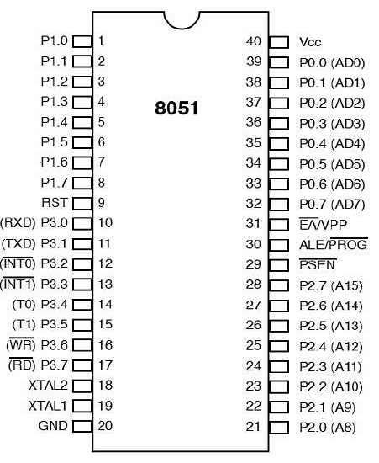

<https://www.tutorialspoint.com/microprocessor/microcontrollers_8051_pin_description.htm>

Pin diagram of SIM 800D

Functional Diagram

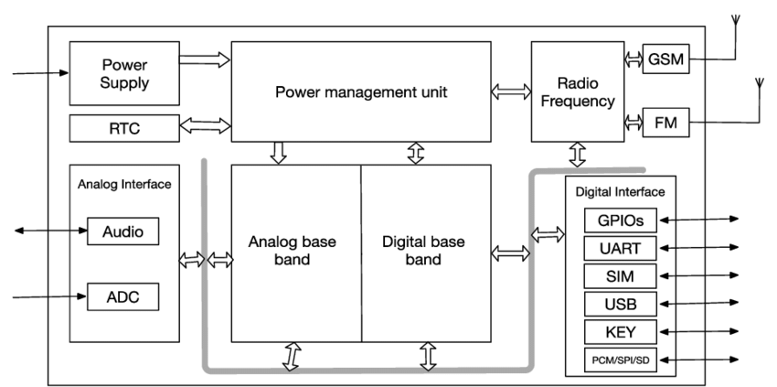

LCD Block Diagram

10k potentiometer diagram

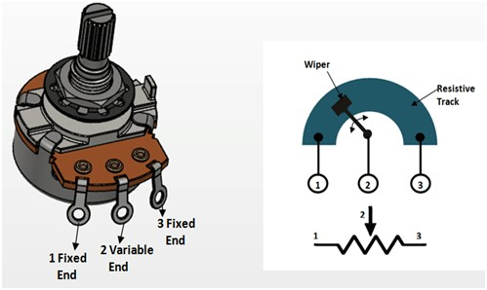

DC buck converter

Ultrasonic Sensors ( HC-SR04)

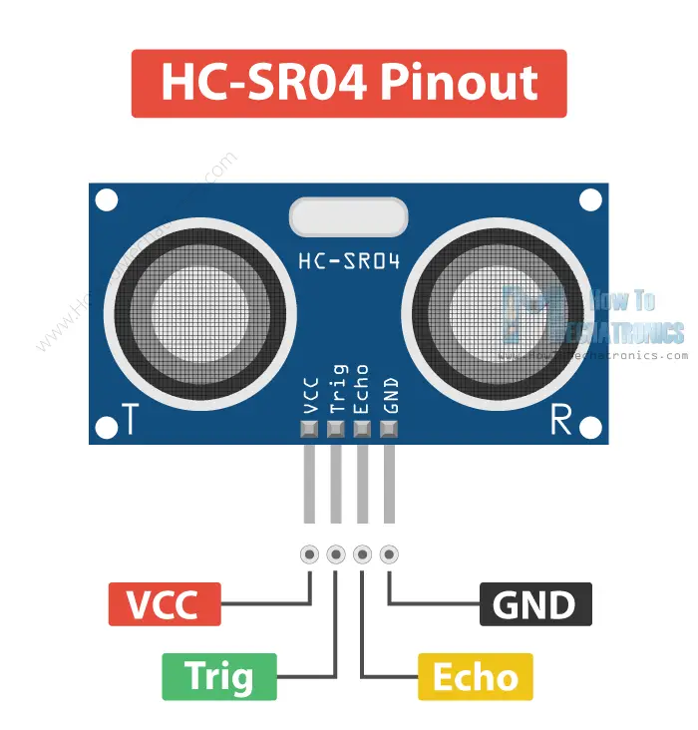

DC Motor

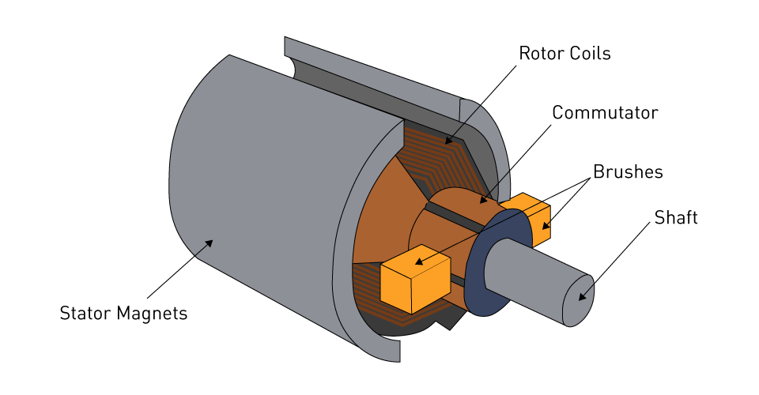

# **Appendix B Datasheet**

Datasheet of 8051

https://datasheetspdf.com/pdf/556271/INTEL/8051/1

Datasheet of LCD

